1. Consider the ER diagram given below to answer the following questions.

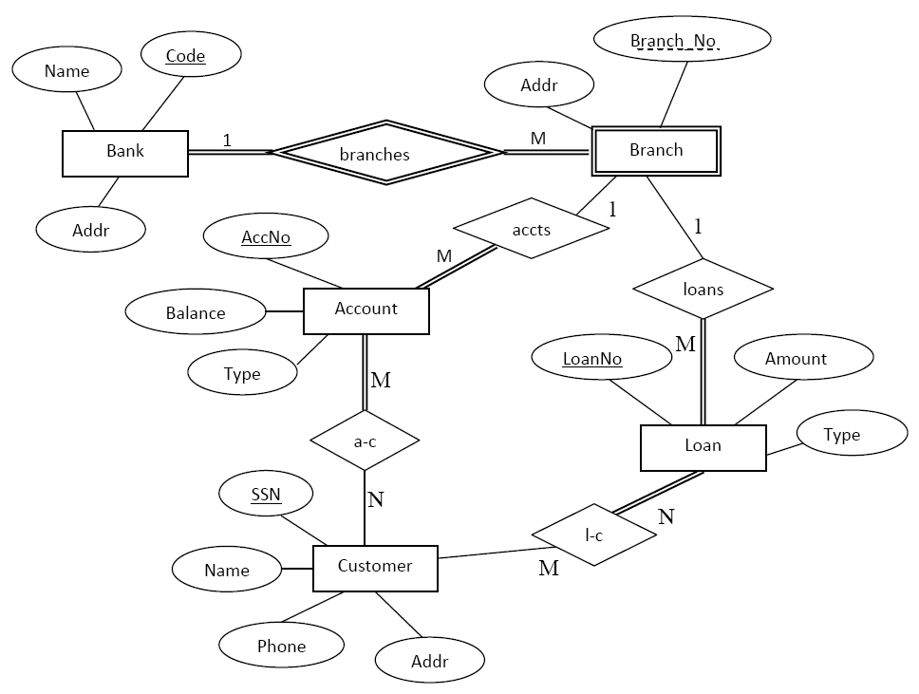

a) List the (non weak) entity types of the ER diagram.

b) Is there a weak entity type? If so, give its name, partial key, and identifying relationship.

c) List concisely the user requirements that led to this ER schema design.

d) Suppose that every customer must have at least one account but is restricted to at most two loans at time, and that a bank branch cannot have more than 1000 loans. How does this show up on the (min, Max) constraints?

e) Different types of accounts can be operated by customers. The bank offers savings accounts, current accounts, fixed-deposit accounts.

Using an E-ER diagram concepts how do you illustrate this requirement.

2. Consider the ER diagram given below to answer the following questions.

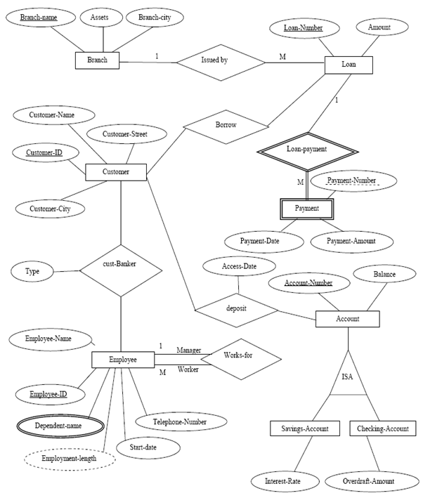

1. a) Name strong entity, weak entity and identifying relationship
   * + 1. b) Can you find any composite attribute? If so name it. If not suggest possible attribute which can behave as composite attribute.
2. c) Identify the ‘Domain’of each given attribute
3. d) Identify Multivalued attribute
4. e) Identify one derived attribute
5. f) Identify 2 descriptive attributes
6. g) Can you find any relationships which totally participatefrom one entity to another? If so what is it?

3. Draw an ER diagram for each scenario given below.

1. A company has several departments. A department has a department code, a department name and an address. Department code is unique for each department. Each department has a supervisor and at least one employee. A supervisor supervises only one department. Employee details such as employee number, employee name, age and position should manage and each employee can be identified from employee number. Employees must be assigned to at least one, but possibly more departments. The company has several projects. Each project has a project code, start date, end date and a title. At least one employee is assigned to a project and an employee might have to work in multiple projects upon the company’s request.
2. The company employee administrative database stores information about the employees, the department and the projects of a company. The following data have been identified in the requirements collection and analysis phase and they are to be represented in the enterprise. The company is organized into departments. Each department has a unique name, a unique number and a particular employee who manages the department. The database keeps track of the start date when an employee began managing the department. A department controls number of projects. Each project has a unique name, unique number and a single location. The database also stores the number of work hours budgeted for each project. The database stores each employees name, pin number, address, salary, sex, birth date, date hired and date he/she terminates employment. An employee is assigned to one department but he/she may work on several projects, which are not necessarily controlled by the same department. The database also keeps tracks of the number of hours an employee already worked on a project and the direct supervisor of each employee if he/she has one. (Note that an employee need not have and assigned supervisor).
3. The ABC Bank is organized into branches. Each branch is located in a main city and it is identified by a unique name. The bank monitors assets of each branch. The customers are identified by their ID number, name and the street and city where they live. They can have accounts and can take out loans. Bank employees are also identified by their ID numbers. The administration stores the name telephone number of each employee, the names of employee’s dependents, and the ID number of the employee’s manager. The bank also keeps track of the employee’s start date and thus the length of employment. The bank offers two types of accounts- savings and current. Accounts can be held by more than one customer and a customer can have more than one account. Each account has a unique account number. The bank maintains a record of each account’s balance and the most recent date the account was accessed. A loan originates at a particular branch and can be held by one or more customers. A loan is identified by a unique loan number, amount and loan payments.

\*\*End of the Tutorial\*\*